Contract Attachment Access Tracking
Implemented by - Vaishali Singh

Requirement
Track and notify Contract Managers whenever a user:
Views a contract attachment
Downloads a contract attachment

Current Platform Behavior
The Contract form uses the standard ServiceNow Attachment Formatter.
For attachment actions:
Download: Supported by the platform.
View: Available only for supported file types through Document Viewer.
DOCX/XLSX/PPTX files: May download directly depending on file type, browser behavior, and platform capabilities.
The native attachment View and Download links do not provide an out-of-the-box mechanism to reliably capture user access events for auditing and notification purposes.

Platform Limitation
ServiceNow does not provide:
Out-of-the-box audit records for attachment views
Out-of-the-box notifications when an attachment is viewed
Out-of-the-box notifications when an attachment is downloaded
A supported configuration to track native attachment formatter actions

Proposed Solution
Implement custom document access controls on the Contract record.

View Document
Create a custom View Document button that:
- Records the user, date/time, contract, and attachment details in a custom audit table.
- Triggers a notification event to the Contract Manager.
- Opens the document for viewing.

Download Document
Create a custom Download Document button that:
- Records the user, date/time, contract, and attachment details in a custom audit table.
- Triggers a notification event to the Contract Manager.
- Initiates the document download.

Audit Table
A custom audit table will capture:
Field | Description
Contract | Contract record
Attachment | Attached document
User | User performing action
Action | View / Download
Date & Time | Timestamp of action

Notifications
Notifications can be sent to:
- Contract Administrator
- Business Owner
- Manager
- Custom recipient group

Recommendation
To ensure complete auditability and notification capability, users should access documents only through custom View Document and Download Document actions rather than the native attachment formatter links.
This approach provides a fully auditable and supportable solution while meeting compliance and tracking requirements.

Note: Native attachment links cannot reliably provide view/download tracking without customization; therefore a custom access mechanism is recommended.

Option 1

Create a table

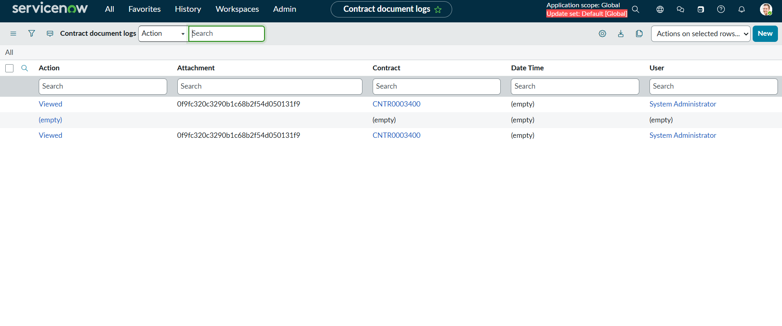

Create Event

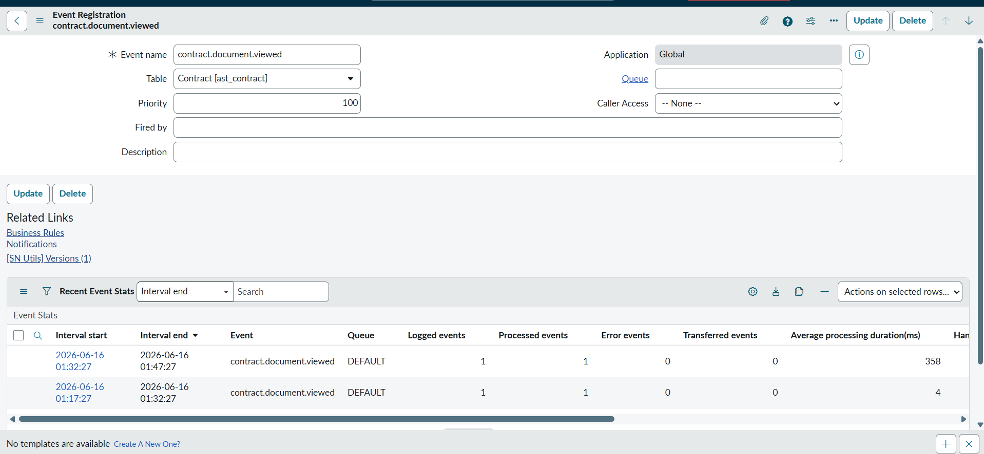

First create ui action

On contract table

Script

var attachmentGR = new GlideRecord('sys_attachment');
attachmentGR.addQuery('table_sys_id', current.sys_id);
attachmentGR.orderByDesc('sys_created_on');
attachmentGR.setLimit(1);
attachmentGR.query();

if (attachmentGR.next()) {

// Audit record
var audit = new GlideRecord('u_contract_document_log');
audit.initialize();
audit.u_contract = current.sys_id;
audit.u_attachment = attachmentGR.sys_id;
audit.u_user = gs.getUserID();
audit.u_action = 'Viewed';
audit.insert();

// Notify manager
gs.eventQueue(
'contract.document.viewed',
current,
gs.getUserDisplayName(),
attachmentGR.file_name
);

action.setRedirectURL(
'/sys_attachment.do?sys_id=' + attachmentGR.sys_id + '&view=true'
);
}

Configure notification

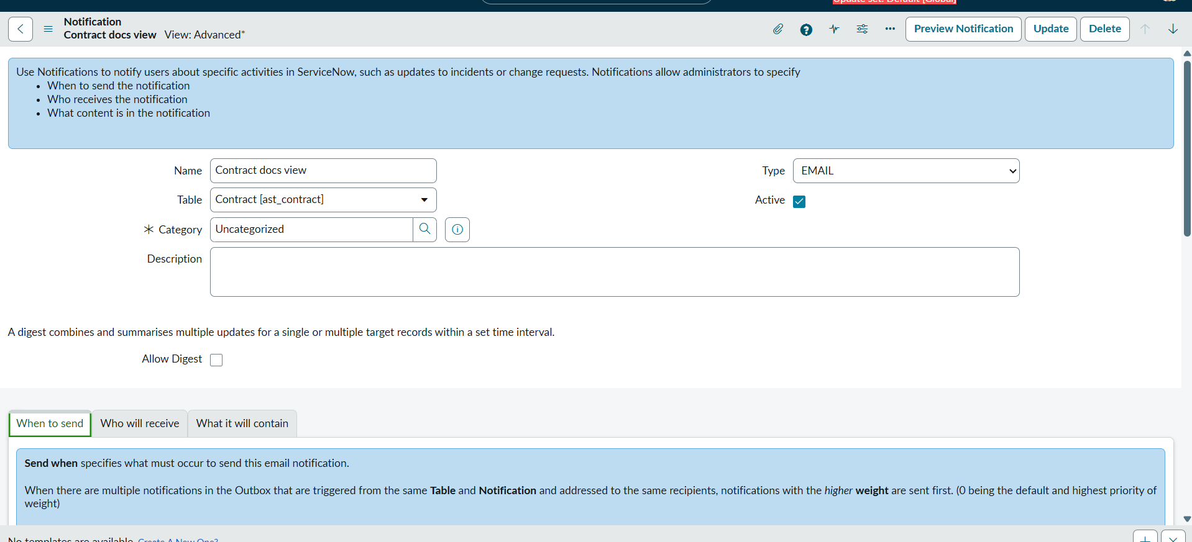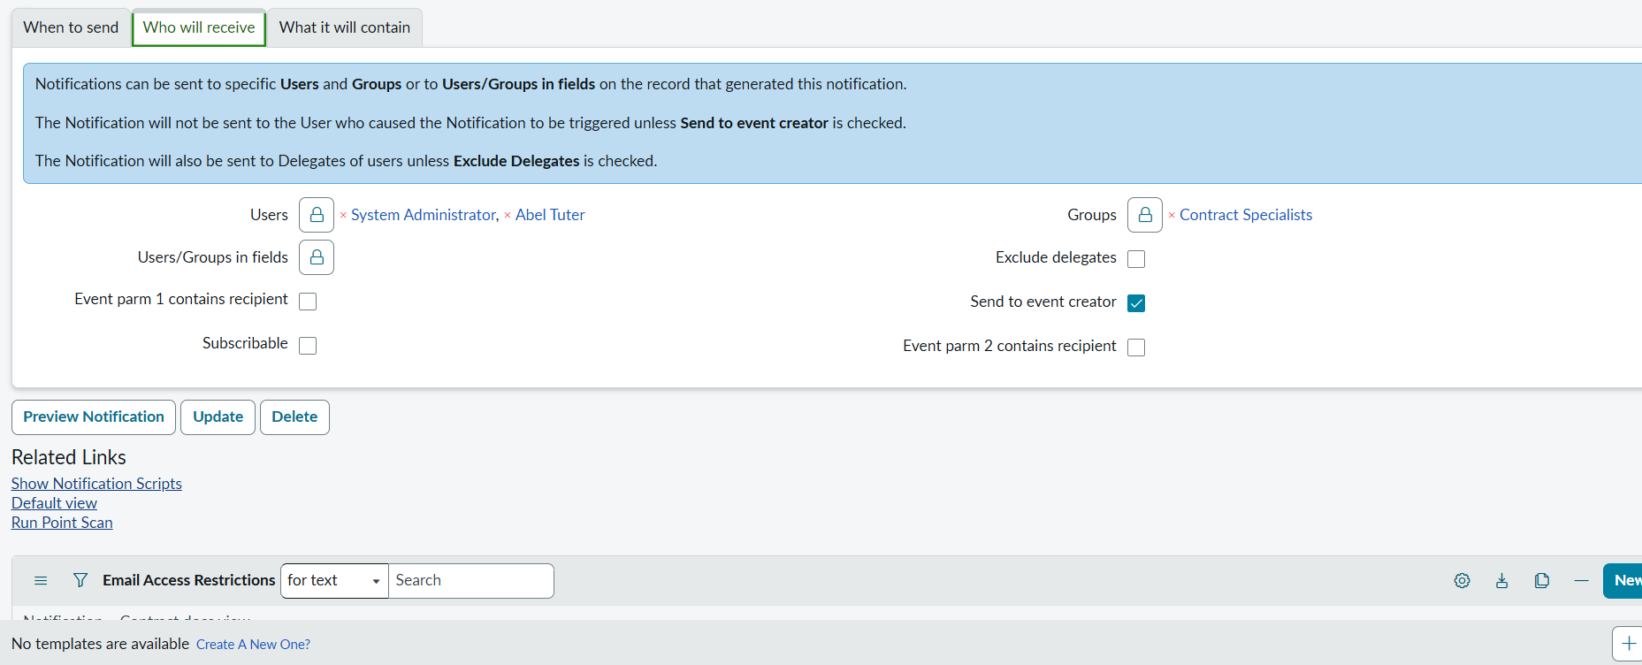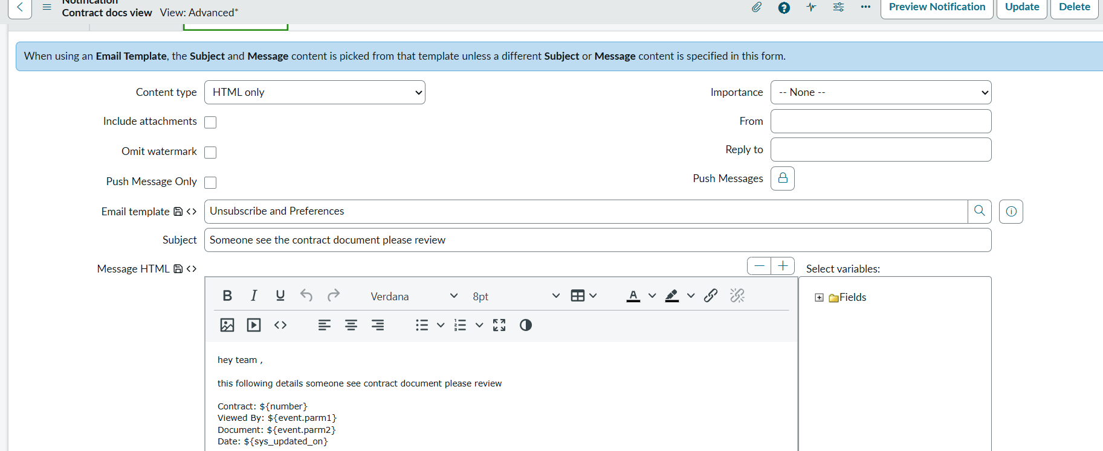

Test

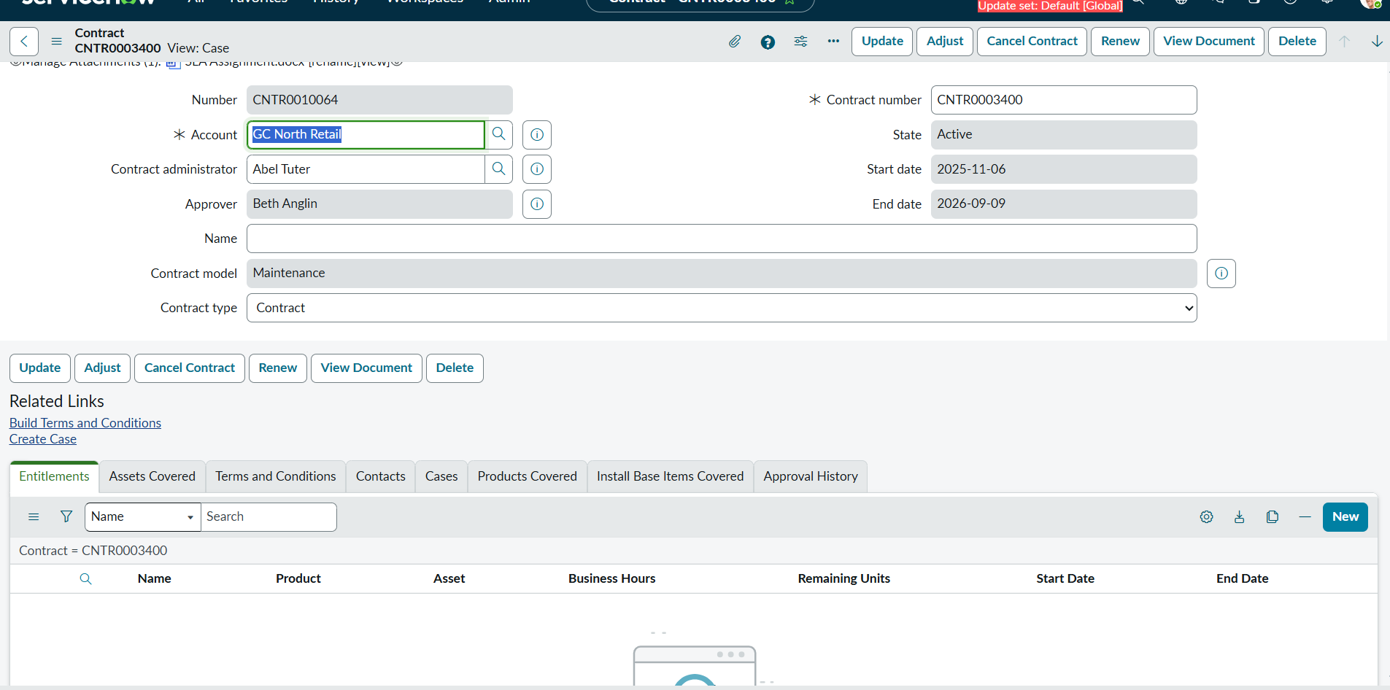

Click ui action view document

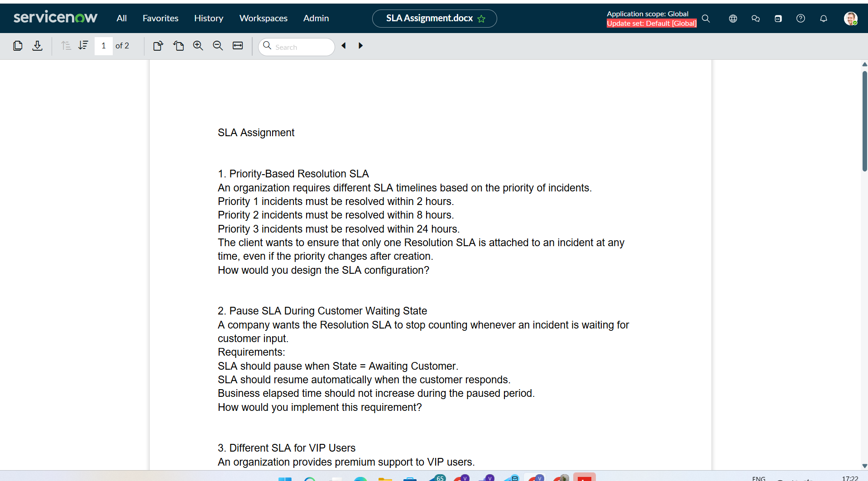

Notification got successfully

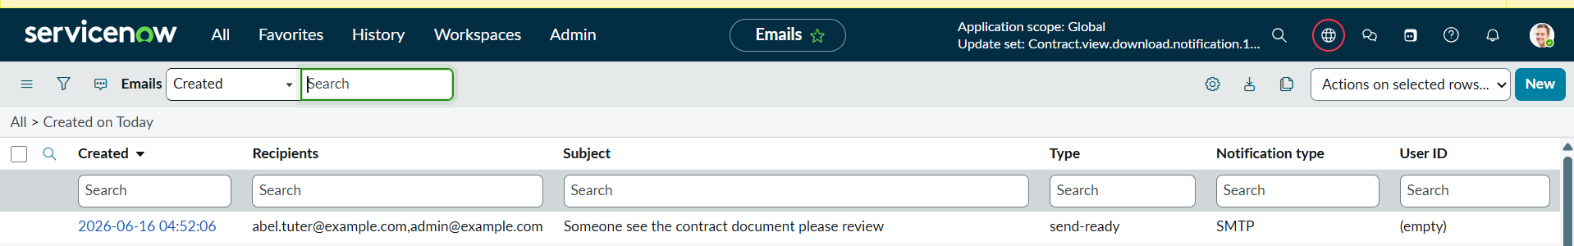

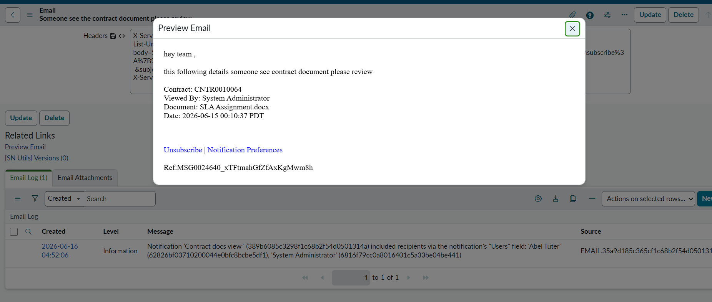

Option 2

Install the plugin

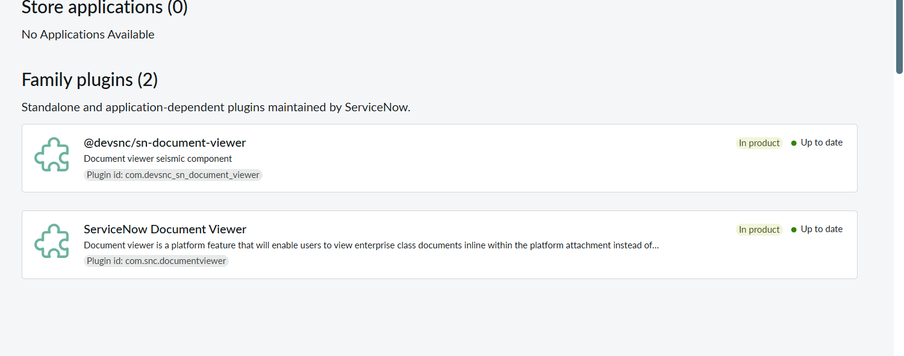

Add this system property

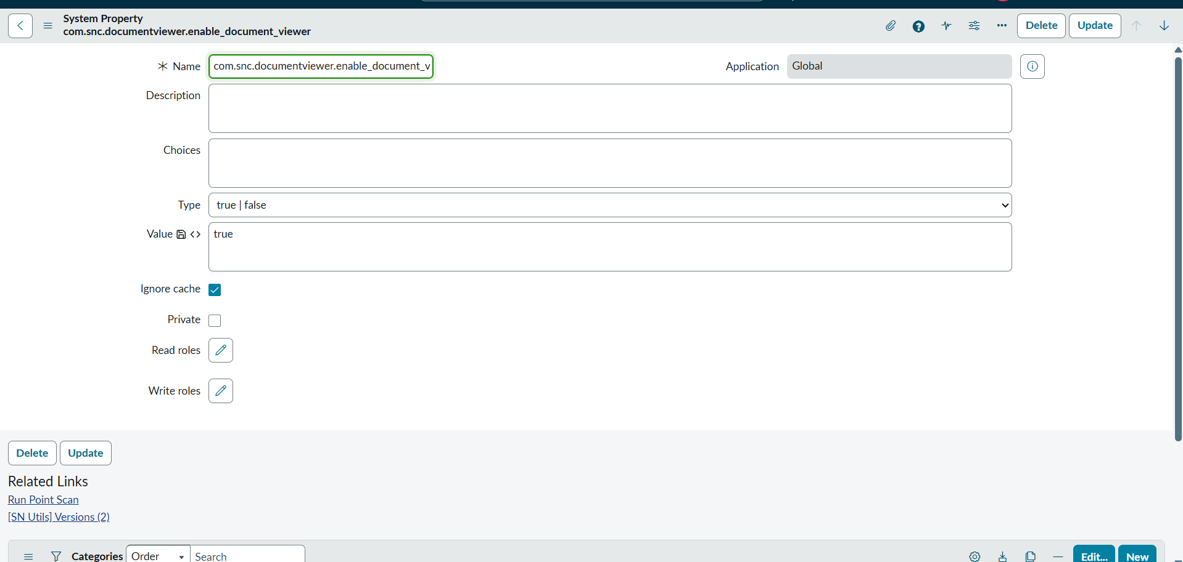
com.snc.documentviewer.enable_document_viewer

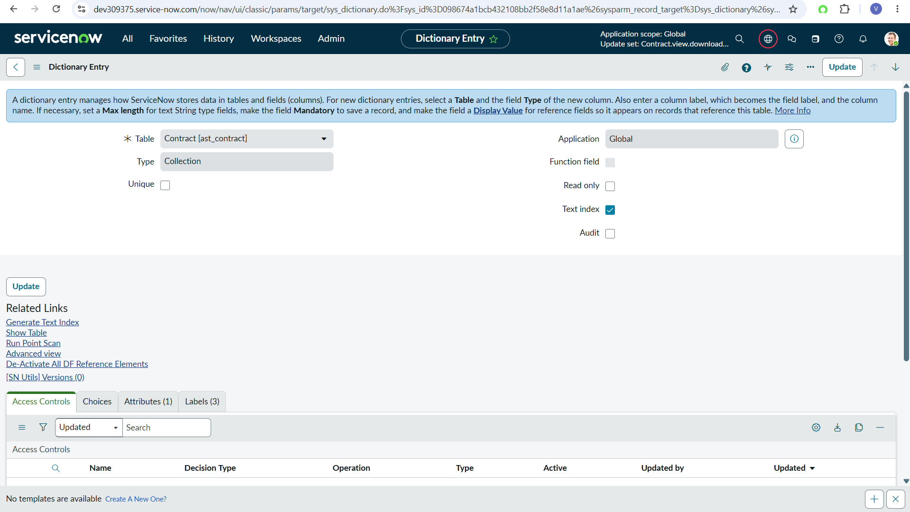

On dictionary open table ast_contract where type collection

In related list add bellow attribute

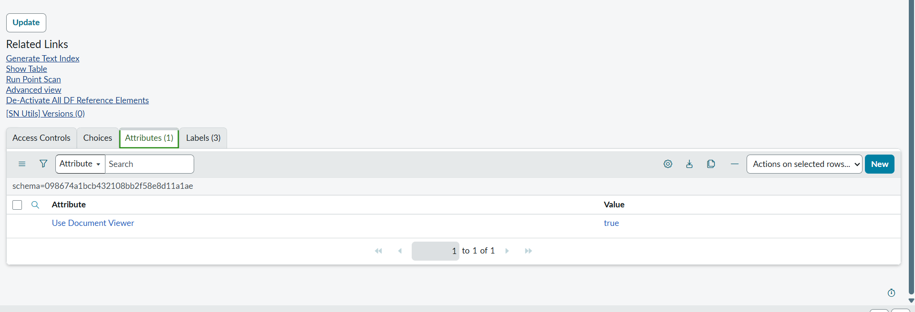

Then open the table you see oob view functionality

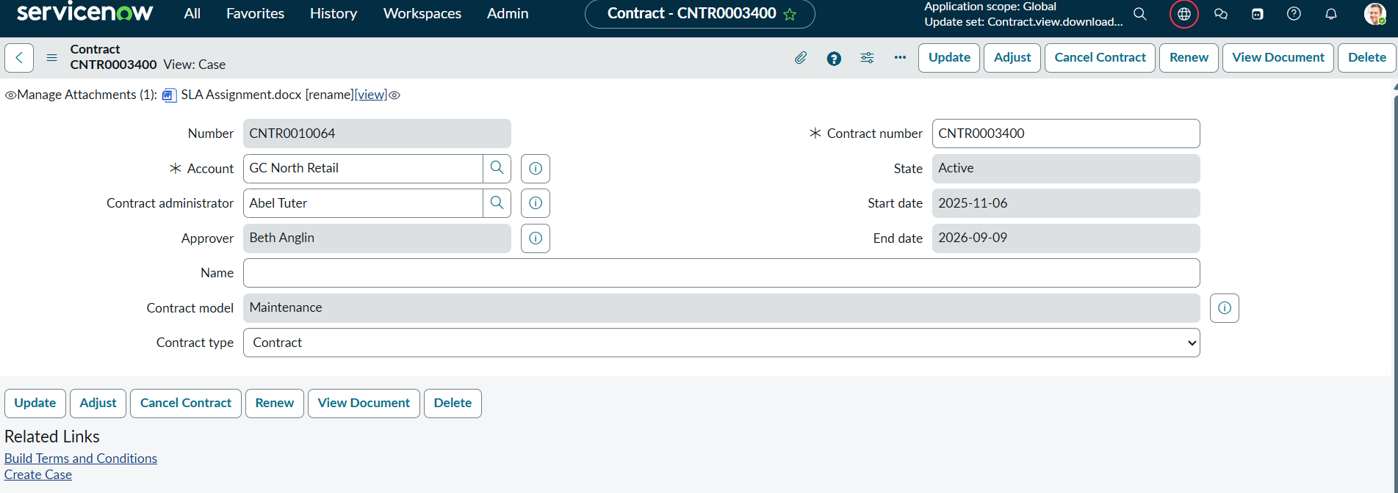

When click

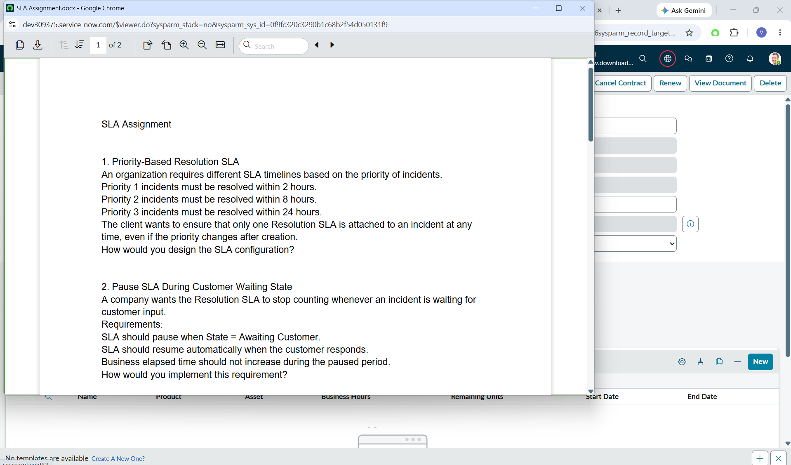

Note -

If Users Click the Native [view] Link
Tracking becomes much harder because ServiceNow's document viewer is internal.

Reason- processor have type java for attachment 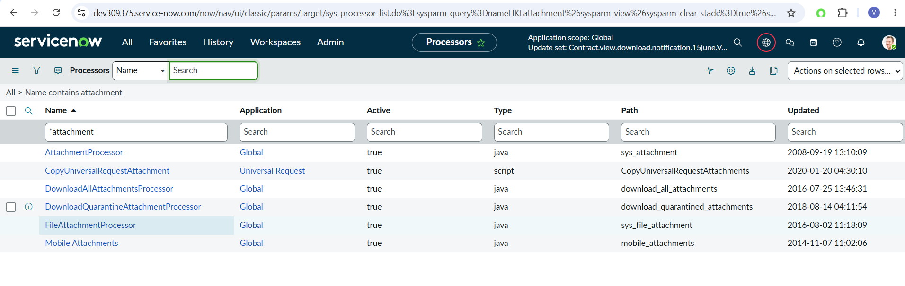
No option here

Recommended -

Hide the native attachment links
Provide a View Document button (option 1)

For Download

Create one event registry
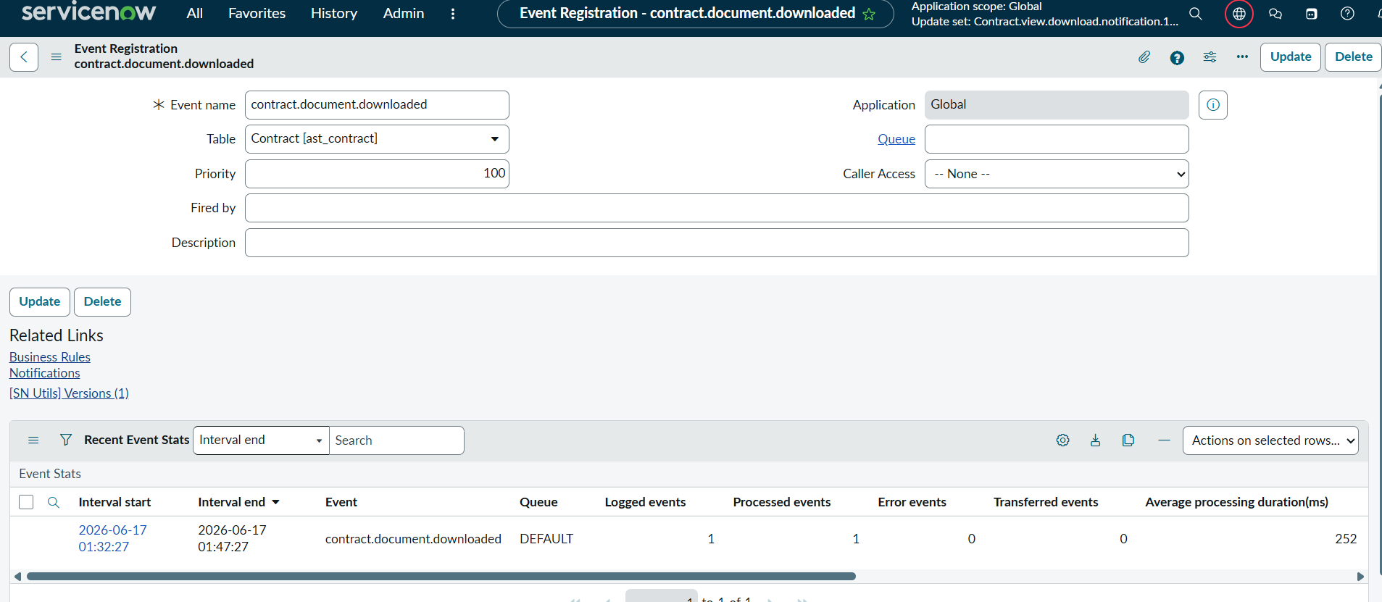

Create ui action on contract table

Script

var attachmentGR = new GlideRecord('sys_attachment');
attachmentGR.addQuery('table_sys_id', current.sys_id);
attachmentGR.orderByDesc('sys_created_on');
attachmentGR.setLimit(1);
attachmentGR.query();

if (attachmentGR.next()) {

var audit = new GlideRecord('u_contract_document_log');
audit.initialize();
audit.u_contract = current.sys_id;
audit.u_attachment = attachmentGR.sys_id;
audit.u_user = gs.getUserID();
audit.u_action = 'Downloaded';
audit.insert();

gs.eventQueue(
'contract.document.downloaded',
current,
gs.getUserDisplayName(),
attachmentGR.file_name
);

action.setRedirectURL('/sys_attachment.do?sys_id=' + attachmentGR.sys_id);
}

Create notification

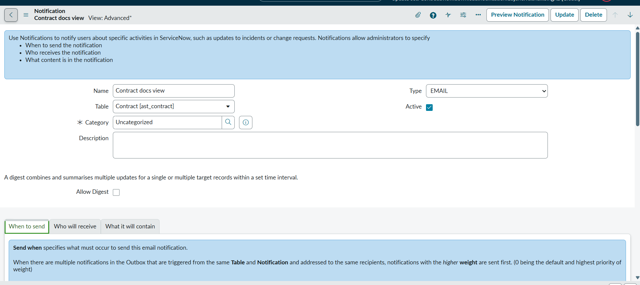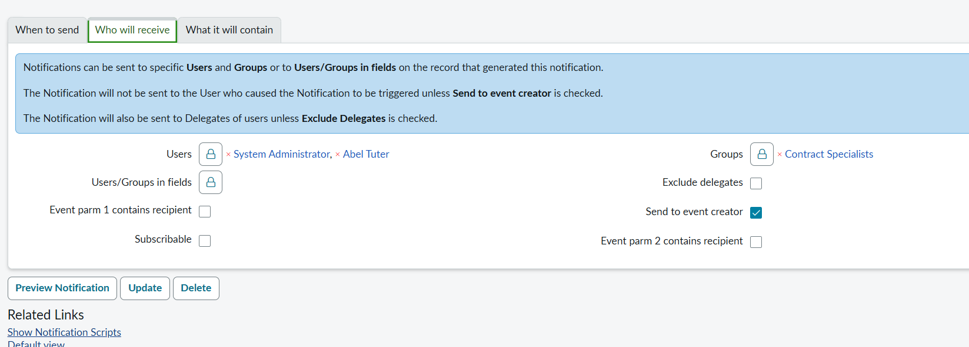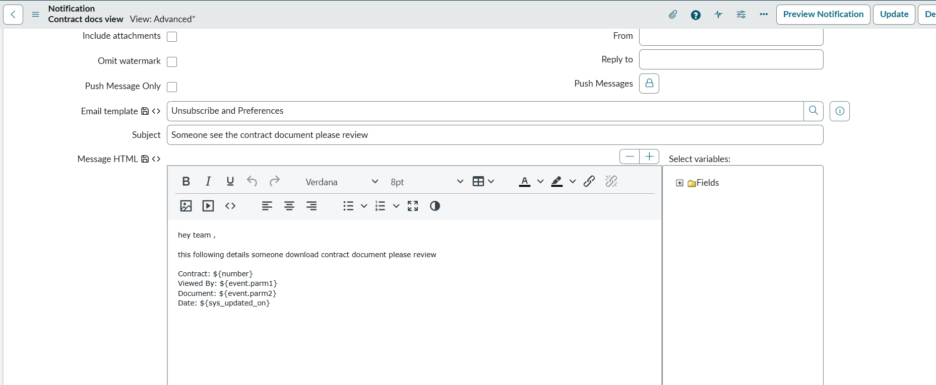

Test

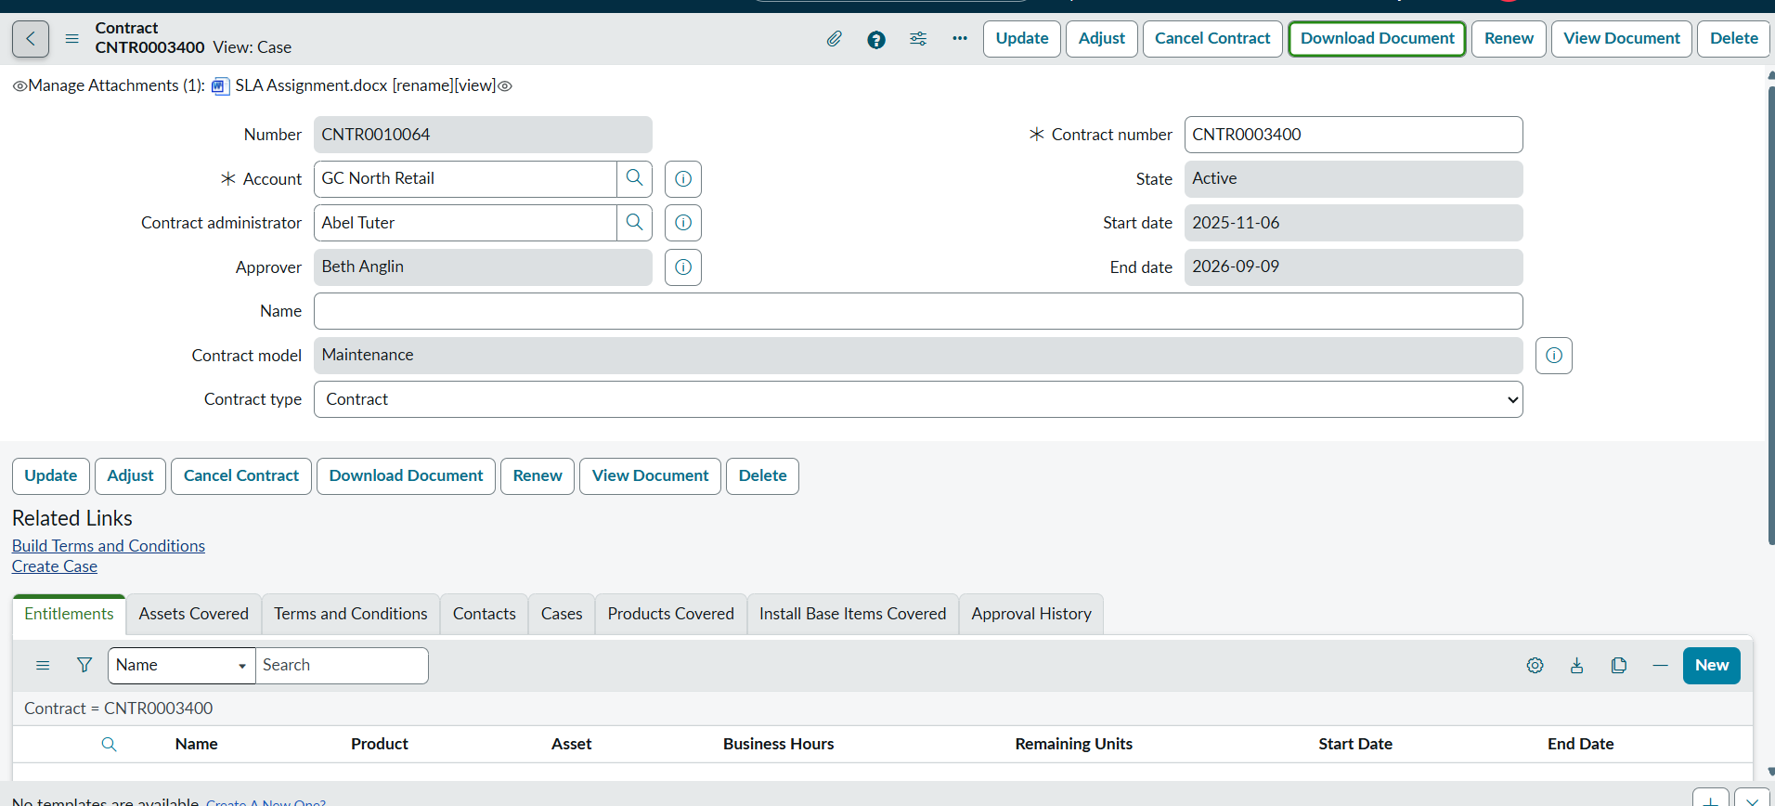

Click download file is downloaded
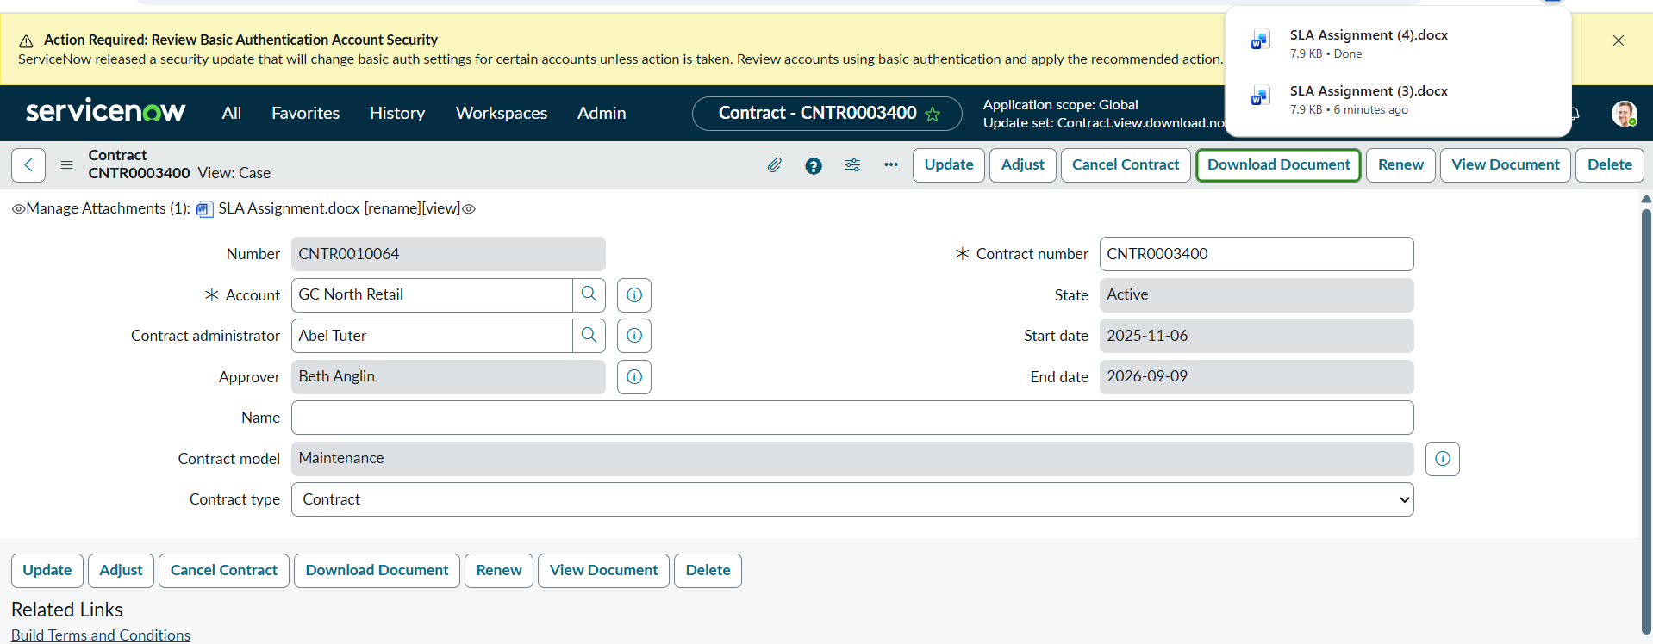

Same time email notification

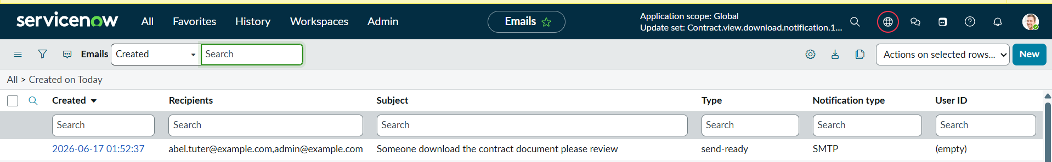

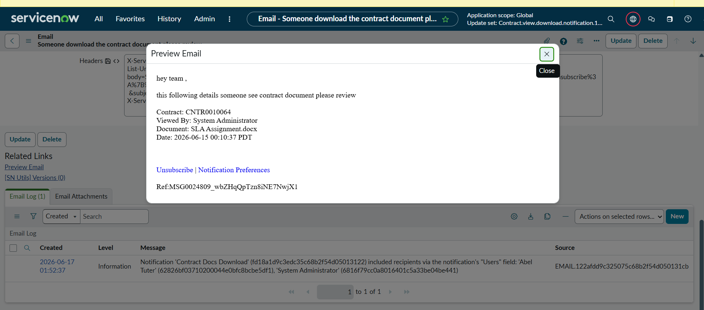

Next For full control

Create Read ACL on sys attachment

if(current.table_name=="ast_contract")

{

if(gs.getUser().isMemberOf('VXT'))

{

answer =true;

}

else

{

answer=false

}

}

